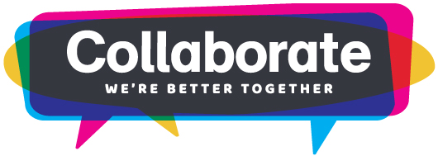

Hi [Manager Name]
I would like to attend the MFOA 2018 Annual Conference & Trade Show, September 19-21, at Sheraton on the Falls Hotel, in Niagara Falls, Ontario. This year the conference theme is “COLLABORATE – We’re Better Together” and it is the premier event for municipal finance professionals to gather, share and discuss information and key challenges we are facing right now. I will learn what’s going on in the industry and how today’s trends can be incorporated into our practices to advance not only my professional development, but the bottom line of [insert organization name]. I’ll also find out about what other municipalities are doing now and discover how they are tackling challenges similar to the ones our organization faces.
This is the event for municipal finance professionals, and encompasses subject matter experts across the industry. The event has a large trade show that had over 40 exhibitors last year, so I will meet new suppliers and learn about the latest products and solutions available. In fact, I can research suppliers for [insert current project you are working on; if you don’t have anything in mind, do not include this sentence].
Additionally, networking is an enormous part of this event; the community aspect is huge! The conference offers a valuable opportunity to connect with more than 300 other municipal finance professionals facing similar challenges. Coming together and hearing what colleagues are doing provides invaluable learning opportunities. This is my chance to join discussions, discover like-minded professionals and create personal relationships with industry peers.
I have attached an outline of the sessions I plan to attend and the exhibitors I plan to visit. [attach session and exhibitor worksheet]
My projected costs for attending the conference are [insert cost from worksheet]. This includes registration, transportation, lodging, events and meals. The estimate assumes that I register by [insert early bird rate deadline date] to receive the early bird rate discount. I have outlined all costs associated with my attendance at the conference, attached.
MFOA’s 2018 Annual Conference is integral to my professional development. Rather than having to attend multiple events throughout the year, this one will cover the entire industry. I will bring back new ideas, best practices and solutions that we can implement right away. Additionally, I will develop an overview of what I have learned and actionable takeaways for the team so that we can work together to move the department and [insert organization name] forward. It’s not just about my personal development. By successfully using what I learn at the MFOA conference, I will help us improve our bottom line.
I hope you will consider my request and grant me approval to attend.
Thank you for your consideration.
Sincerely,
[Your name]

